**COMPUTER SCIENCE PROJECT REPORT**

NAME: Shreyash Sridhar Iyengar

CLASS: XII-A

YEAR: 2018-2019

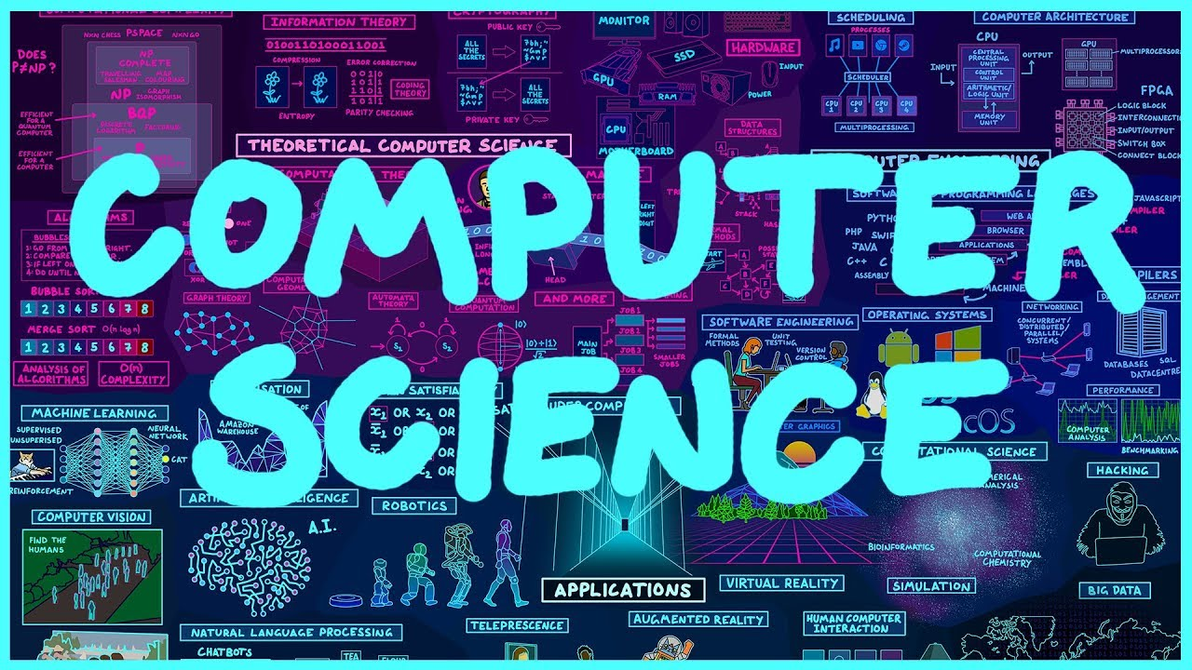

**ABU DHABI INDIAN SCHOOL, ABU DHABI**

**CERTIFICATE**



**This is to certify that Master Shreyash Sridhar Iyengar of Class 12 bearing the A.I.S.S.C.E. registration code has satisfactorily completed the ‘Computer Science Project’ entitled to him for the academic year 2018-2019 as prescribed by the Central Board of Secondary Education (CBSE), New Delhi.**

**Date Of Examination:**

**Teacher In-Charge**

**Internal Examiner External Examiner**

**ACKNOWLEDGEMENT**

**Firstly, I would like to express my profound gratitude to my computer science teacher, Mrs. Lekshmi Sunil, for giving me the opportunity to do this project. I am grateful for my teacher’s exemplary guidance and constant encouragement throughout this endeavor. This project has given me a deeper insight of the fundamentals of computer science, algorithmic solutions and methods of coding.**

**I would also like to express my deep sense of gratitude to my parents and my school for providing me with the necessary facilities to facilitate this project and without whom this project would have never been possible.**

**TABLE OF CONTENTS**

|  |  |  |
| --- | --- | --- |
| S NO. | TOPIC | PAGE NUMBER |
|  | INTRODUCTION | 5 |
|  | GENERAL OOP CONCEPTS | 6 |
|  | HEADER FILES | 7 |
|  | CLASS | 8 |
|  | FUNCTIONS | 9 |
|  | FLOWCHART | 10 |
|  | SYSTEM SPECIFICATIONS | 11 |
|  | SOURCE CODE | 12 |
|  | OUTPUTS | 27 |
|  | ADVANTAGES | 32 |
|  | DISADVANTAGES | 32 |
|  | CONCLUSION | 32 |

* **INTRODUCTION**

The program, **‘Raise Your Hand to Help Society’** System (RYHTS) has been created from an administrator point of view which involves making use of concepts of object-oriented programming for booking, addition and manipulation of flight, passenger and transaction data securely. The program is an example of Object-Oriented Programming (OOP) as it implements classes, objects and data file handling.

In a society where there is a mix of well-off people as well as people in a dire state of economic and social conditions, it is our duty to help those in need. Thus, the RYHTS program was born. The program’s aim is to provide a system and a platform for the public to provide aid and help to the poor and needy people in our society. It is a no-profit initiative with all the funds going for the benefit of the poor. One can donate food, clothe or even land or money for housing. We have several packages for each option.





* **GENERAL OOP CONCEPTS**

The object-oriented approach of programming views a problem in terms of objects involved rather than a procedure for doing it. This is facilitated using classes. The basic concepts of OOP which are briefly described below:

1. *DATA ABSTRACTION*

Data abstraction refers to the act of representing only the essential features of a program without including the background details or explanations.

2. *POLYMORPHISM*

Polymorphism is the ability for a message to be interpreted and processed in more than one form.

3. *MODULARITY*

The act of partitioning the program into individual components is called modularity. Modularity reduces the complexity of the program and creates several well defined, documented units within a program.

4. *ENCAPSULATION*

The wrapping up of data and operations or functions (that operate on the data) into a single unit (called a class) is called encapsulation. Encapsulation, together with data abstraction makes the program simple and easy to use.

* **HEADER FILES**

1.<iostream.h>

To perform input and output operationS

2.<fstream.h>

To perform basic file operations

3.<conio.h>

To include functions like getch( ) and clrscr( ) and display coloured text.

4.<stdio.h>

To include functions like gets( ) and puts( ).

5.<string.h>

To include functions like strcpy( ) and strcmpi( ).

6.<process.h>

To execute the termination of the program when needed.

7.<iomanip.h>

To set and adjust the width of the dsiplayed text.

* **Class**

Name: service

* Data Members:
* Private:

1. char name[20] // name of user
2. char place[20] // residence
3. char gen[7]; //gender

* Public:

1. int idcode
2. int foodcost
3. int clothescost
4. int clothescost
5. int housecost
6. int totalcost
7. char foodtype[20]
8. char houseloc [50]
9. char clothestype[20]

* Member Functions:
* Public:

1. void getdata( ) //To input the required details of the user
2. int getidcode( ) // To return the id number of the user
3. char* getname( ) // To return the name of the user
4. char* getplace ( ) // To return the residence of the user
5. void display( ) // To display all the details and donation transactions of the user

* **Functions**

1. **main( )** //Starting of the program. Contains the main body of the program.
2. **menu( )** //Displays the main menu
   * 1. create( ) // To create a social account for the user
     2. Search( ) // To search the user’s social account
     3. display ( ) // To call the display function of class service
     4. exit(0) // Terminates the program
3. **food( )** // Handles the necessary procedures for donation of food
4. **clothes( )** // Handles the necessary procedures for donation of clothes
5. **house( )** // Handles the necessary procedures for donation of house

**FLOWCHART**

CREATE FUNCTION

IF LOGIN CREDENTIALS EXIST

MENU

1. CREATE
2. SEARCH
3. DISPLAY
4. EXIT

IF LOGIN CREDENTIALS ARE WRONG

FOOD FUNCTION

1. DONATION OF FOOD
2. DONATION OF CLOTHES
3. DONATION OF CLOTHES

CLOTHES FUNCTION

HOUSE FUNCTION

DISPLAY

DISPLAYS THE FOLLOWING:

NAME, IDCODE, GENDER, PLACE, DONATIONS MADE FOR FOOD (FOODCOST, FOODTYPE), CLOTHES (CLOTHESCOST, CLOTHESTYPE) & HOUSE (HOUSECOST, HOUSETYPE)

* **System Specifications**

1. Name: *HP Business PC*
2. Operating System: *Windows 10(64-bit)*
3. Processor: *Intel®Core(TM)i3-6100 3.70GHz*
4. RAM: 4GB
5. C
6. ompiler: *Code::Blocks 17.12 (GNU GCC Compiler; C++)*

* **Source Code**

#include <iostream>

#include <stdio.h>

#include <conio.h>

#include <string.h>

#include <process.h>

#include <cstring>

#include <fstream>

void create ();

void Search();

void food();

void clothes();

void house();

void update();

using namespace std;

class service

{

char name[20], place[20], gen[7];

public:

int idcode=0,foodcost=0,clothescost=0,housecost=0,totalcost=0;

char foodtype[20], houseloc[50], clothestype[20];

void getdata()

{

cout<<"\n ENTER YOUR NAME, IDCODE, GENDER (MALE/FEMALE/OTHER) AND PLACE OF RESIDENCE\t";

cin>>name>>idcode>>gen>>place;

}

int getidcode ()

{

return (idcode);

}

char* getname()

{

return(name);

}

char* getplace()

{

return(place);

}

void display()

{

cout<<"\n NAME = \t"<<name;

cout<<"\n IDCODE = \t"<<idcode;

cout<<"\n GENDER = \t"<<gen;

cout<<"\n PLACE = \t"<<place;

cout<<"\n Donations made for:-";

cout<<"\n"<<foodcost<<" for :"<<foodtype;

cout<<"\n"<<clothescost<<" for :"<<clothestype;

cout<<"\n"<<housecost<<" for : Housing";

cout<<"\n Totalcost = "<<totalcost;

}

};

void update()

{

fstream fsoc ("Social.dat", ios :: in);

fstream ftemp ("Temp.dat", ios:: out);

service s;

char name [20];

cout <<"\n Enter name to update your details \t";

while (fsoc.read((char*)&s, sizeof (s)))

{ if (strcmp(s.getname(),name)==0)

{ cout<<"\n Enter new details";

s.getdata();

ftemp.write ((char*)& s, sizeof (s));

}

else

ftemp.write ((char*)& s, sizeof (s));

}

fsoc.close();

ftemp.close();

remove("Social.dat");

rename ("Temp.dat", "Social.dat");

}

int main ()

{

service s;

int ch;

do

{

cout<<"\n WELCOME TO RAISE YOUR HAND TO HELP SOCIETY (RYHTHS) PROCESSING SYSTEM";

cout<<"\n MENU";

cout<<"\n 1. Create a Social Donation Account";

cout<<"\n 2. Access your Account details";

cout<<"\n 3. Display";

cout<<"\n 4. Exit";

cout<<"\n Enter your choice \t";

cin>>ch;

switch (ch)

{

case 1: create();

break;

case 2: Search();

break;

case 3: s.display();

break;

}

} while (ch<=3);

return 0;

}

void create()

{ fstream fsoc ("Social.dat", ios::in | ios::out);

service s;

char ch;

cout<<"\n You have chosen to create a Social Donation Account";

s.getdata();

fsoc.write((char *)& s, sizeof(s));

cout<<"\n 1. Do you wish to donate food?(Y OR N)";

cin>>ch;

if (ch=='Y')

{int chf;

cout<<"\n You have chosen to donate food.";

cout<<"\n Choose type of food package you wish to donate";

cout<<"\n 1. Lunch/Dinner meal with beverage (AED 30)";

cout<<"\n 2. Breakfast with beverage (AED 25)";

cout<<"\n 3. Beverages (AED 5)";

cout<<"\n 4. Fruits (AED 10)";

cout<<"\n 5. Exit/Continue";

cout<<"\n Enter your number of choice \t";

cin>>chf;

do

{ switch (chf)

{

case 1: strcpy (s.foodtype, "Lunch/Dinner Meal with Beverage");

s.foodcost += 30;

fsoc.write ((char*)& s, sizeof (s));

break;

case 2: strcpy (s.foodtype, "Breakfast Meal");

s.foodcost += 25;

fsoc.write ((char*)& s, sizeof (s));

break;

case 3: strcpy (s.foodtype, "Beverages");

s.foodcost += 5;

fsoc.write ((char*)& s, sizeof (s));

break;

case 4: strcpy (s.foodtype, "Fruits");

s.foodcost += 10;

fsoc.write ((char*)& s, sizeof (s));

break;

}

} while (ch<=4);

s.totalcost += s.foodcost;

fsoc.write ((char*)& s, sizeof (s));

cout<<"\n You have successfully donated \t"<<s.foodcost<<" for \t"<<s.foodtype<<" .";

cout<<"\n The total cost is \t"<<s.totalcost;

cout<<"\n Thank you for choosing RAISE YOUR HAND TO HELP SOCIETY (RYHTHS) PROCESSING SYSTEM";

s.display();

}

cout<<"\n 2. Do you wish to donate clothes? (Y OR N)";

cin>>ch;

if (ch=='Y')

{

int chc;

cout<<"\n You have chosen to donate food.";

cout<<"\n Choose type of clothing you wish to donate";

cout<<"\n 1. Winter Clothing (Full Set)(2 pieces)(AED 70)";

cout<<"\n 2. Cotton Jumpers (3 pieces) (AED 20)";

cout<<"\n 3. Children Wear ( 2 pieces) (AED 15)";

cout<<"\n 4. Undergarments for Men/Women(4 pieces)(AED 15)";

cout<<"\n 5. Exit/Continue";

cout<<"\n Enter your number of choice \t";

cin>>chc;

do

{ switch (chc)

{

case 1: strcpy (s.clothestype, "Winter Clothing (Full Set)(2 pieces)");

s.clothescost += 70;

fsoc.write ((char*)& s, sizeof (s));

break;

case 2: strcpy (s.clothestype, "Cotton Jumpers (3 pieces)");

s.clothescost += 20;

fsoc.write ((char*)& s, sizeof (s));

break;

case 3: strcpy (s.clothestype, "Children Wear ( 2 pieces)");

s.clothescost += 5;

fsoc.write ((char*)& s, sizeof (s));

break;

case 4: strcpy (s.clothestype, "Undergarments for Men/Women(4 pieces)");

s.clothescost += 10;

fsoc.write ((char*)& s, sizeof (s));

break;

case 5: continue;

}

} while (ch<=5);

s.totalcost += s.clothescost;

fsoc.write ((char*)& s, sizeof (s));

cout<<"\n You have successfully donated \t"<<s.clothescost<<" for \t"<<s.clothestype<<" .";

cout<<"\n The total cost is \t"<<s.totalcost;

cout<<"\n Thank you for choosing RAISE YOUR HAND TO HELP SOCIETY (RYHTHS) PROCESSING SYSTEM";

s.display();

}

cout<<"\n 3. Do you wish to provide housing facilities? (Y OR N)";

cin>>ch;

if (ch == 'Y')

{

char name [20], yes;

int found = 0;

int chh, cost;

cout<<"\n You have chosen to contribute towards housing facilities.";

cout<<"\n Do you wish to: ";

cout<<"\n 1. Donate money?";

cout<<"\n 2. Provide land for housing?";

cout<<"\n Enter your choice \t";

cin>>chh;

do

{ switch (chh)

{

case 1: cout<<"\n Enter amount of money you wish to donate \t";

cin>>cost;

s.housecost += cost;

s.totalcost += s.housecost;

fsoc.write ((char*)& s, sizeof (s));

break;

case 2: cout<<"\n Please enter your name \t";

cin>>name;

cout<<"Please confirm your personal details";

while (fsoc.read((char *)&s, sizeof (s)))

{ if (strcmp(s.getname(),name)== 0)

{s.display();

found = 1;

break;

}

if (found == 0)

{cout<<"\n You do not have a social account. Please enter Y to create an account. \t";

cin>>yes;

switch(yes)

{

case 'Y' : create();

break;

default : create();

}

}

}

char opt;

cout<<"\n Do you wish to change the details (Y/N)?";

cin>>opt;

switch (opt)

{

case 'Y': update();

break;

default: update();

}

cout<<"\n Enter the location/address of land for providing housing \t";

cin>>s.houseloc;

fsoc.write ((char*)& s, sizeof (s));

break;

default : cout<<"\n Enter amount of money you wish to donate \t";

cin>>cost;

s.housecost += cost;

s.totalcost+= s.housecost;

fsoc.write ((char*)& s, sizeof (s));

break;

}

} while (ch<=2);

s.display();

}

fsoc.close();

}

void Search()

{ fstream fsoc ("Social.dat", ios::in | ios::out);

service s;

int regno, found = 0,ch;

cout<<"\n You have chosen to search for your Social Donation Account";

cout<<"\n Enter your IDCODE to search for your account \t";

cin>>regno;

while ( fsoc.read( (char *) & s, sizeof(s) ) )

{

if(s.getidcode()== regno)

{ cout<<"\n Your account has been found";

s.display();

found = 1;

cout<<"\n 1. Do you wish to donate food?(Y OR N)";

cin>>ch;

if (ch=='Y')

{

int chf;

cout<<"\n You have chosen to donate food.";

cout<<"\n Choose type of food package you wish to donate";

cout<<"\n 1. Lunch/Dinner meal with beverage (AED 30)";

cout<<"\n 2. Breakfast with beverage (AED 25)";

cout<<"\n 3. Beverages (AED 5)";

cout<<"\n 4. Fruits (AED 10)";

cout<<"\n 5. Exit/Continue";

cout<<"\n Enter your number of choice \t";

cin>>chf;

do

{ switch (chf)

{

case 1: strcpy (s.foodtype, "Lunch/Dinner Meal with Beverage");

s.foodcost += 30;

fsoc.write ((char*)& s, sizeof (s));

break;

case 2: strcpy (s.foodtype, "Breakfast Meal");

s.foodcost += 25;

fsoc.write ((char*)& s, sizeof (s));

break;

case 3: strcpy (s.foodtype, "Beverages");

s.foodcost += 5;

fsoc.write ((char*)& s, sizeof (s));

break;

case 4: strcpy (s.foodtype, "Fruits");

s.foodcost += 10;

fsoc.write ((char*)& s, sizeof (s));

break;

}

} while (chf<=4);

s.totalcost += s.foodcost;

fsoc.write ((char*)& s, sizeof (s));

cout<<"\n You have successfully donated \t"<<s.foodcost<<" for \t"<<s.foodtype<<" .";

cout<<"\n The total cost is \t"<<s.totalcost;

cout<<"\n Thank you for choosing RAISE YOUR HAND TO HELP SOCIETY (RYHTHS) PROCESSING SYSTEM";

s.display();

}

cout<<"\n 2. Do you wish to donate clothes? (Y OR N)";

cin>>ch;

if (ch=='Y')

{

int chc;

cout<<"\n You have chosen to donate clothes.";

cout<<"\n Choose type of clothing you wish to donate";

cout<<"\n 1. Winter Clothing (Full Set)(2 pieces)(AED 70)";

cout<<"\n 2. Cotton Jumpers (3 pieces) (AED 20)";

cout<<"\n 3. Children Wear ( 2 pieces) (AED 15)";

cout<<"\n 4. Undergarments for Men/Women(4 pieces)(AED 15)";

cout<<"\n 5. Exit/Continue";

cout<<"\n Enter your number of choice \t";

cin>>chc;

do

{ switch (chc)

{

case 1: strcpy (s.clothestype, "Winter Clothing (Full Set)(2 pieces)");

s.clothescost += 70;

fsoc.write ((char*)& s, sizeof (s));

break;

case 2: strcpy (s.clothestype, "Cotton Jumpers (3 pieces)");

s.clothescost += 20;

fsoc.write ((char*)& s, sizeof (s));

break;

case 3: strcpy (s.clothestype, "Children Wear ( 2 pieces)");

s.clothescost += 5;

fsoc.write ((char*)& s, sizeof (s));

break;

case 4: strcpy (s.clothestype, "Undergarments for Men/Women(4 pieces)");

s.clothescost += 10;

fsoc.write ((char*)& s, sizeof (s));

break;

case 5: continue;

}

} while (chc<=5);

s.totalcost += s.clothescost;

fsoc.write ((char*)& s, sizeof (s));

cout<<"\n You have successfully donated \t"<<s.clothescost<<" for \t"<<s.clothestype<<" .";

cout<<"\n The total cost is \t"<<s.totalcost;

cout<<"\n Thank you for choosing RAISE YOUR HAND TO HELP SOCIETY (RYHTHS) PROCESSING SYSTEM";

s.display();

}

cout<<"\n 3. Do you wish to provide housing facilities? (Y OR N)";

cin>>ch;

if (ch == 'Y')

{

char name [20], yes;

int found = 0;

int chh, cost;

cout<<"\n You have chosen to contribute towards housing facilities.";

cout<<"\n Do you wish to: ";

cout<<"\n 1. Donate money?";

cout<<"\n 2. Provide land for housing?";

cout<<"\n Enter your choice \t";

cin>>chh;

do

{ switch (chh)

{

case 1: cout<<"\n Enter amount of money you wish to donate \t";

cin>>cost;

s.housecost += cost;

s.totalcost += s.housecost;

fsoc.write ((char*)& s, sizeof (s));

break;

case 2: cout<<"\n Please enter your name \t";

cin>>name;

cout<<"Please confirm your personal details";

while (fsoc.read((char *)&s, sizeof (s)))

{ if (strcmp(s.getname(),name)== 0)

{s.display();

found = 1;

break;

}

if (found == 0)

{cout<<"\n You do not have a social account. Please enter Y to create an account. \t";

cin>>yes;

switch(yes)

{

case 'Y' : create();

break;

default : create();

}

}

}

char opt;

cout<<"\n Do you wish to change the details (Y/N)?";

cin>>opt;

switch (opt)

{

case 'Y': update();

break;

default: update();

}

cout<<"\n Enter the location/address of land for providing housing \t";

cin>>s.houseloc;

fsoc.write ((char*)& s, sizeof (s));

break;

default : cout<<"\n Enter amount of money you wish to donate \t";

cin>>cost;

s.housecost += cost;

s.totalcost+= s.housecost;

fsoc.write ((char*)& s, sizeof (s));

break;

}

} while (chh<=2);

s.display();

}

break;

if (found == 0)

{cout<<"\n Your Social Donation account does not exist. Proceeding to create a social account";

create();

fsoc.close();

}

}

}

}

* **OUTPUTS**
* MAIN MENU

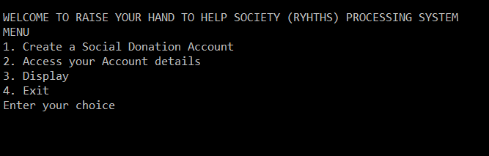

* CREATION OF NEW USER

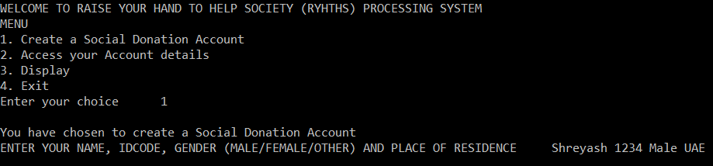

* DONATION OF FOOD

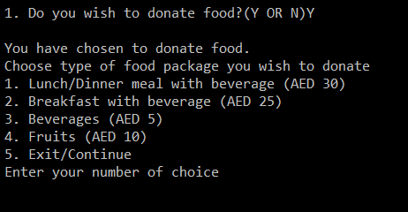

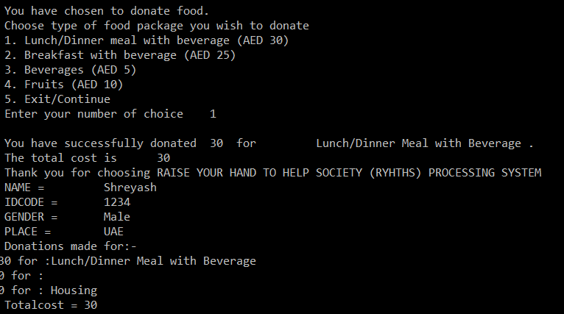

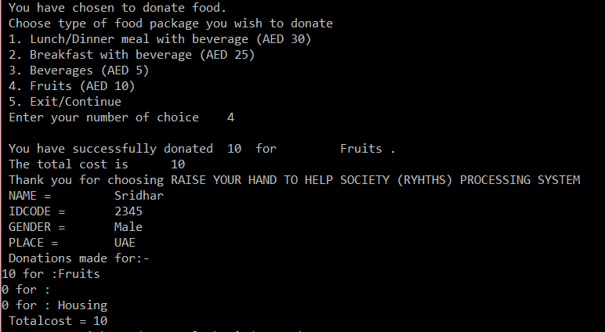

* DONATION OF CLOTHES

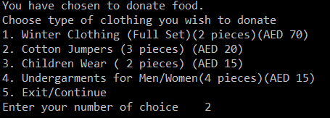

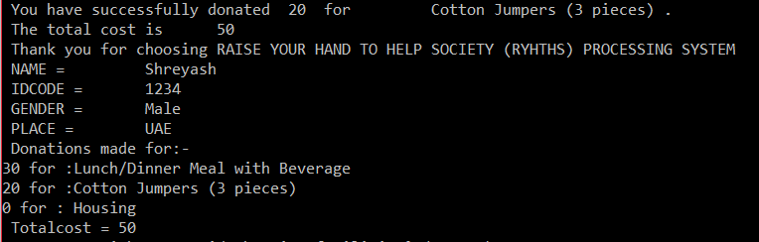

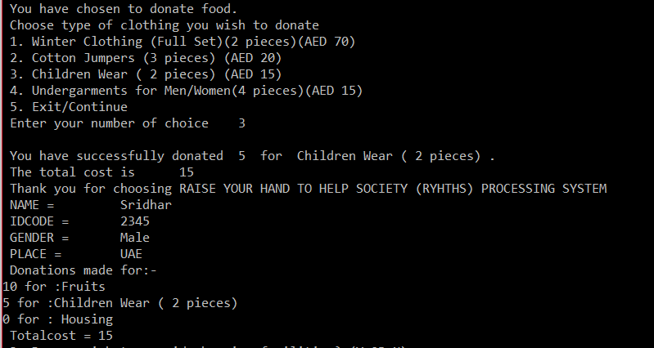

* DONATION FOR HOUSING

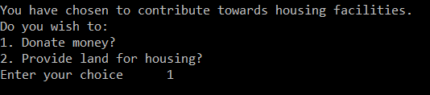

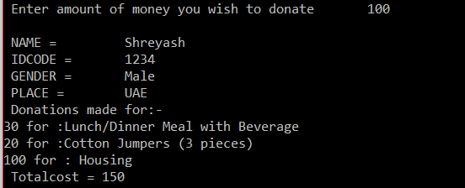

* IF ACCOUNT DOES NOT EXIST

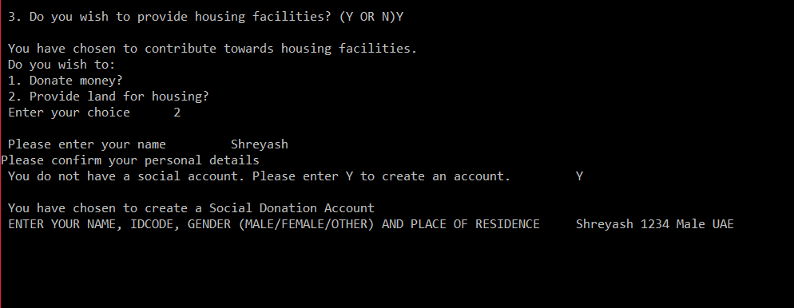

* SEARCH/DISPLAY

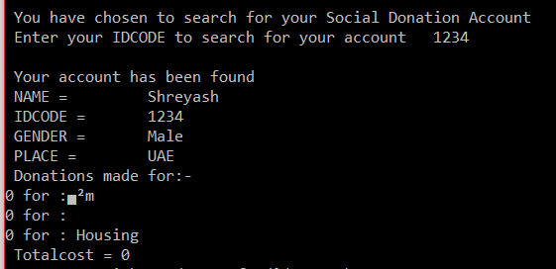

* PROGRESSION OF FUNCTIONS

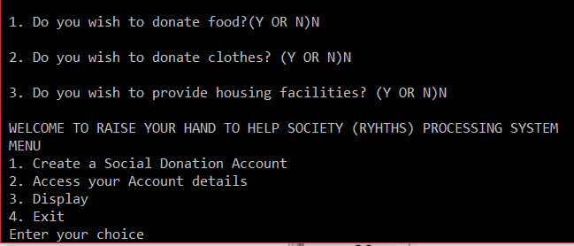

* **Advantages**
* Provides the user a simple and easy interface.
* Implementation of data hiding keeps the information of the passenger and their bank accounts confidential.
* Reduces the work and effort of the user by a great extent due to functions like search and display.
* Runs on Turbo C++, a free and easily available compiler.
* System allows the user to provide service to the poor and needy.
* **Disadvantages**
* Program modifications required to function on a different  
  compiler.
* Cannot book more than one flight at a time by a passenger.
* Abrupt program terminations can occur if incorrect data type values are entered at certain places.
* Multiple trials and testing can lead to scores of function abnormalities and expected output may not appear
* **CONCLUSION**

***Program illustrating concepts of OOP (classes, objects, data file handling) and perfection has been successfully executed by the menu driven program.***